How to get to The Elburton Hypnotherapy Suite
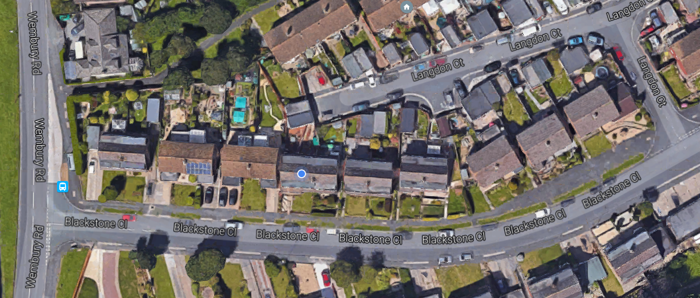
The Elburton Hypnotherapy Suite
15, Blackstone Close,
Elburton
Plymouth.
PL9 8UQ

- The Elburton Hypnotherapy Suite is located in Langdon Court at the back of Blackstone Close (see diagram above).
- Please park in Blackstone Close and walk through Langdon Court to The Elburton Hypnotherapy Suite – a sign in the window will indicate you are in the right place.
- Please ring the doorbell when you arrive for your appointment and I will come out to greet you.

Please do not park in Langdon Court due to limited parking spaces

- If you have mobility issues please speak to me prior to your appointment and I can make appropriate arrangements for you.
I look forward to meeting you soon.
Warm regards
Caroline

